

Module Code & Module Title
CS6P05NI Final Year Project
Assessment Weightage & Type
5% FYP Proposal Semester
2024 Autumn
PROJECT TITLE: School Management System
Student Name: Aagaman Mainali
London Met ID: 22068131
College ID: np01cp4a220472
Internal Supervisor: Subin Chitrakar
External Supervisor: Rubek joshi
Assignment Due Date: 12/4/2024
Assignment Submission Date: 12/4/2024
Word Count: 2671
I confirm that I understand my coursework needs to be submitted online via Google Classroom under the relevant module page before the deadline in order for my assignment to be accepted and marked. I am fully aware that late submissions will be treated as non-submission and a mark of zero will be awarded.
Table of Contents
1. Introduction: 1
1.1 Introduction to the Topic 1
1.2 Current Scenario: 2
1.3 Problem Statement : 2
1.4 The project as a solution: 2
1.5 Aims and Objectives 3
1.5.1 Aim: 3
1.5.2 Objectives 3
2. Background: 4
2.1 About the End User/ Client: 4
2.2 Similar Project: 5
2.2.1. Fedena Community Edition 5
2.2.2 OpenSIS 6
2.2.3. Moodle 7
2.3 Comparison Of the project: 8
3. Methodologies: 8
3 .1 Considered Methodology: 9
3.1.1 Feature-Driven Development (FDD): 9
3.1.2 Agile Scrum: 10
3.2 Selected Methodology: 11
3.3 Work Break Down Structure: 13
3.4 Gantt chart: 14
4. Analysis Review: 15
4.1 Progress Summary: 15
4.2 Progress Table: 16
4.3 System Architecture: 17
4.4 ERD: 18
4.5 Use Case Diagrams 19
4.6 Sequence Diagram: 22
4.7 Activity Diagram: 25
4.8 Collaboration Diagram 29
4.9 Class Diagram 33
4.10 Wireframe: 36
4.11 UI designs: 40
4.12 Development Status With Proof : 42

Table of Figures:
Figure 1:Inncrease in schooling managemnet in system (MordorIntelligence, 2024) 1
Figure 2: Fedena Schooling sysytem 5
Figure 3:OpenSIS school managemnet Software 6
Figure 4:Moodle Software 7
Figure 5:Development process for FDD model (Grorapid Labs, 20024) 9
Figure 6:Process involved during scrum (Bhaskar S, 2024) 10
Figure 7:Kanban Board for Software development (Simon Buehring, 2024) 11
Figure 8: WBS image for the system 13
Figure 9: Gantt Chart System 14
Figure 10:MVT flow in Django (Pain, n.d.) 17
Figure 11:ERD for the system 18
Figure 12: Use case for Login Processs 19
Figure 13: UseCase For register 19
Figure 14: Use Case for holiday Creation 20
Figure 15: UseCase For Fee Payment 20
Figure 16: Use For Examinations 21
Figure 17: Sequence for login 22
Figure 18:Sequence for Register 22
Figure 19:Sequence For holiday 23
Figure 20:Sequence for Fee Payment 23
Figure 21:Sequence for Report generation 24
Figure 22:Sequence for Examination UI 24
Figure 23:Activity diagram for Examination 25
Figure 24:Activity diagram for make payment 26
Figure 25:Activity for Login Page 27
Figure 26:Activity UML for register 28
Figure 27:Activity for Holiday 29
Figure 28:Collaboration for Report Generation 29
Figure 29:Collaboration for Event 30
Figure 30:Collaboration for Examination 30
Figure 31:Collaboration for FeesPayment 31
Figure 32:Collaboration for Holiday Creation 31
Figure 33:Collaboration for login 32
Figure 34:Collaboration for registration 32
Figure 35:class diagram for Event 33
Figure 36:Class Diagram for login 33
Figure 37:Class Diagram for Fees 33
Figure 38:CLassDiagram for Exam 34
Figure 39: Class Diagram for holiday 34
Figure 40:ClassDiagram For forget Password 34
Figure 41:Classdiagram For Notifications 35
Figure 42:ClassDiagram For Register 35
Figure 43:Wireframe for Events page 36
Figure 44:Wireframe for ForgotPasswordPage 36
Figure 45:Wireframe for Holiday Page 37
Figure 46:Wireframe for Login 37
Figure 47:Wireframe for OTP page 38
Figure 48:Wireframe for Register 38
Figure 49:Wireframe for profile 39
Figure 50:Wireframe for Login 39
Figure 51:UI design for login Page 40
Figure 52:UI for SignUp page 40
Figure 53:UI for OTP verification Page 41
Figure 54:UI for forget Password page 41
Figure 55: User Extended Model 42
Figure 56:Password length less that 8 43
Figure 57:Error message 43
Figure 58:Validation With diffrent Paasword 44
Figure 59:Validation Failed 44
Figure 60:Using the user that already exists: 45
Figure 61:Validation failed due to Unique constraint 45
Figure 62:SignIN with Proper Data 46
Figure 63:New user created 46
Figure 64:Using Wrong Password 47
Figure 65:Login Validation Failed 47
Figure 66:Using Correct Password field 48
Figure 67:Redirected To login 48
Figure 68:OTP sent 49
Figure 69:Entered OTP 49
Figure 70:Redirected to login Page 50

1. Introduction:

1.1 Introduction to the Topic
Administrative tasks like maintaining student attendance, handling grades, processing funds, and keeping records are frequently done by hand in traditional educational institutions. These procedures usually use outdated software or paper-based methods, which results in inefficiencies, human error, and a delay in information exchange (theschoolmanagement, 2024).There is little opportunity to enhance the overall educational experience because teachers and administrators spend a lot of time on repetitive tasks.

The School Management System (SMS), on the other hand, provides an advanced solution that organizes and automates these essential tasks, greatly improving the accuracy and efficiency of school operations. SMS removes the need for manual data entry and paper-based records by digitizing procedures including student enrollment, attendance tracking, grade management, and fee collecting. Additionally, the system guarantees that parents, teachers, and kids have real-time access to critical information, which promotes improved communication and prompt decision-making. The SMS additionally shields private information from unwanted access thanks to its integrated security features. The School Management System is an essential tool for modern schools since, in contrast to old approaches, it improves overall management of educational institutions, minimizes errors, and streamlines administrative operations.
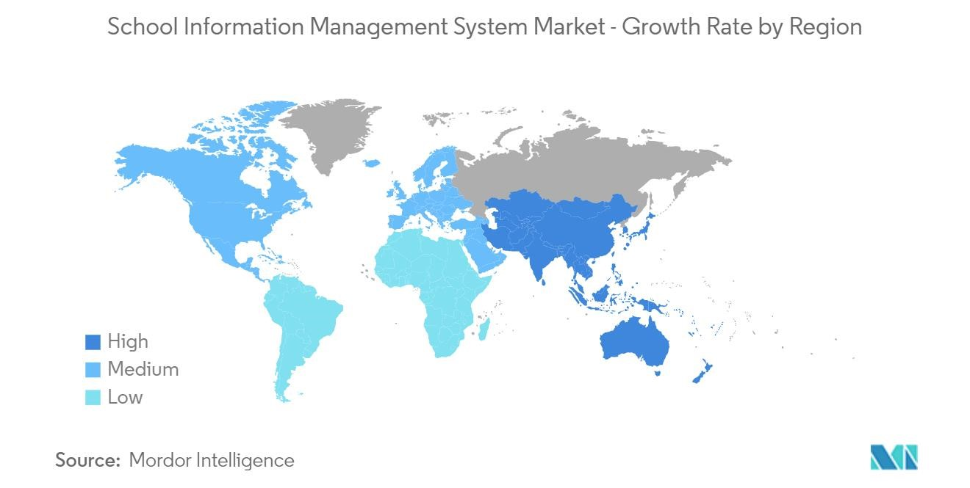
Figure 1:Inncrease in schooling management in system (MordorIntelligence, 2024)

1.2 Current Scenario:
In the era of digitalization, educational institutions are under increasing pressure to improve student engagement and optimize their administrative procedures. Traditional systems frequently use manual processes, which cause delays, mistakes, and inefficiencies. A study published by the U.S. Department of Education’s National Center for Education Statistics, as of 2022, 75% of public schools reported using cloud-based systems for at least some of their administrative functions (Verified Market Research, 2024).

1.3 Problem Statement :
In Nepal, however, many educational institutions still face significant challenges due to a lack of streamlined platforms for managing various educational and administrative tasks. As a result, administrators and students experience a decentralized approach to communication and data management. These inefficiencies can hinder academic achievement, lower student satisfaction, and limit the potential for institutional growth and development. (edigitalnepal, 2024)
The need for modernization is becoming more and more obvious, even if Nepal's educational system is digitizing more slowly than other developed countries. Many institutions encounter obstacles including inadequate funding and shortages in technology expertise. However, the advantages of switching to a digital system enhancing communication, streamlining administrative procedures, and improving learning outcomes are becoming increasingly clear.

1.4 The project as a solution:
This is where this project is useful. By providing a comprehensive, cloud-based solution that improves administrative tasks and student participation, the proposed educational system seeks to eliminate the current inefficiencies. The system will have several features that are intended to automate and streamline important procedures in educational establishments, facilitating communication between staff, students, and administrators. These characteristics, which provide flexibility and scalability for educational institutions of various sizes, are specifically designed to meet the demands of Nepal's educational environment.

1.5 Aims and Objectives

1.5.1 Aim:
Enhancing Traditional schooling system: This project's main goal is to create a School Management System that improves student involvement through constant updates and notifications while reducing administrative operations. The system will use modern technology to automate essential processes including student enrollment, attendance tracking, grade management, and fee collecting.

1.5.2 Objectives
- Affordable Access to Technology: By end of April 2024, design and implement a cost-effective educational management system that aligns with the budget constraints of 80% of educational institutions in Nepal, ensuring its affordability and sustainability.
- Improvement of Administrative Efficiency: Reduce the amount of paperbased administrative work by 50% within the first six months of deployment by automating procedures including event registration, fee collecting, student enrollment, and attendance tracking.
- Commitment to the law and regulations: Verify that the system satisfies all local laws regarding security, privacy, and education under Nepal’s Personal Data Protection Act.
- Promoting Student Engagement and Learning: E By implementing features like event registration, exam management, and real-time notifications of academic activities, increase student involvement by 40% in the first academic year.
- Automated Attendance Recording (Future Work): In the coming Future integrate a fingerprint-based attendance system that automates attendance tracking, aiming to eliminate manual record-keeping and reduce errors by 90%.
- Administrative Tools: Launch a complete admin page with CMS features, enabling administrators to efficiently manage notifications, schedule events, and create and update content, reducing administrative workload by 30%.

2. Background:

2.1 About the End User/ Client:
The primary end users of the proposed School Management System (SMS) include the following stakeholders within educational institutions:
- School Administrators
Leaders in a school have the mandate of overseeing the general running of the school through overseeing issues such as students’ attendance, fees, grades, and records. The SMS will assist the administrators by eliminating bureaucracy that comes with human errors together with increasing efficiency and establishing a control point for all the administrative activities. They will then be able to spend more time on chronic strategic stakeholder planning and decision-making for institutional more time.
- Teachers
This is a primary secret of teachers in that they are often working on a number of fronts in the classroom, marking assignments, in having to ensure that students attend their classes as expected. The SMS will automate these processes by enabling digital documentation of mechanical work; providing instant student information; and enable grading. This will enable teachers to spend most of their time offering quality education and quality time to students.
- Students
Any learning institution revolves around learners and that is why the SMS puts the focus on students. Amid free access to grades and attendance, as well as school announcements and other important notices, students can be aware of their progress and engage in their schooling process. The SMS will also assist the students to facebook with the teachers and to get access to other resources easil
System in Nepalese Educational Institutions

The target clients of the SMS are mainly educational institutions of Nepal: private, relatively small schools and large state schools. Such institutions struggle with the issues, such as separated communication, the absence of effective administrative hierarchy, and the restricted usage of progressive technology. To overcome these challenges, the SMS is designed to meet these needs sustainably at a low cost and integrates with the context of Nepalese education systems.

2.2 Similar Project:
In this section, discuss of some of the school management systems and educational technology were looked into that have been adopted to improve administrative hindrances and students’ interaction. These projects are similar of the proposed e-School system for a community college, It is essential for the educational management to apply information systems in order to build efficient relationship between schools; the discussed below projects are among the best examples of the successful implementation of information systems in educational environment.

2.2.1. Fedena Community Edition
Fedena is an open-source educational management software through which many schools can be operated easily through a number of services like student management, grade reports, absent records, and communication solutions. Fedena is the tool which helps in automating all the working process and grants the students, teachers, parents immediate data access.
- Key Features:
- Student and staff management.
- School calendar management
- Timetable management
- Online fee management
- Relevance:
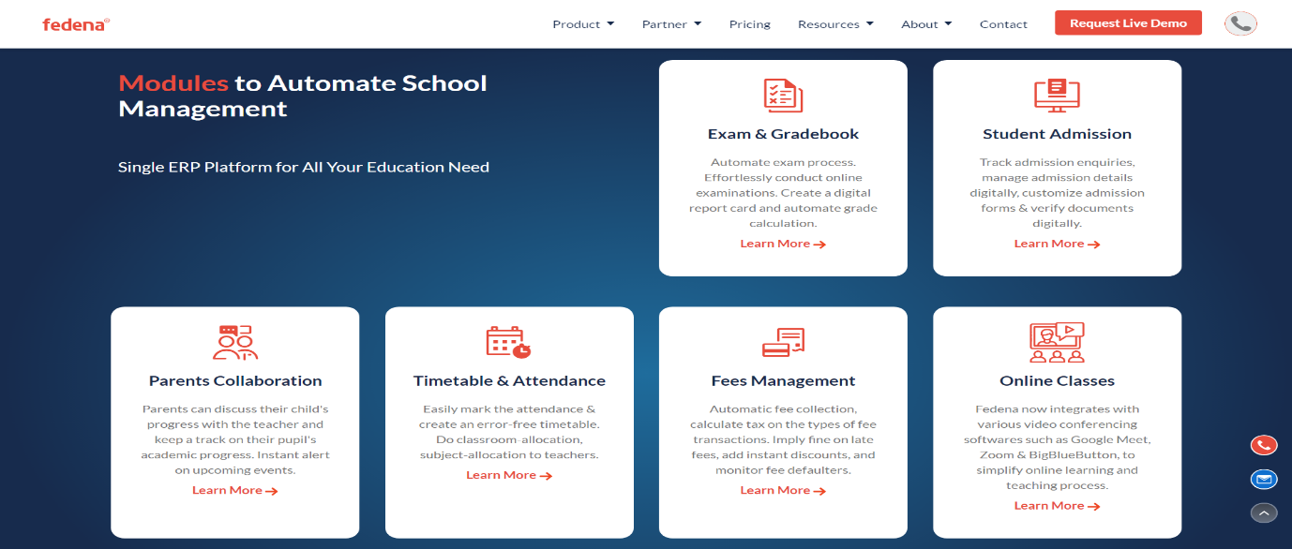
Some of the features of Fedena like attendance management, were referenced as it suited the objectives of the system.
Figure 2: Fedena Schooling sysytem

2.2.2 OpenSIS
Overview:
OpenSIS is a open-source student information system which is suitable for K-12 schools and colleges and universities. For tangible benefits, it enables an institution to keep track of records such as student data, performance, attendance, and it helps in scheduling). OpenSIS is a versatile product capable of easily scaling to meet the requirements of an institution.
Key Features:
- Student record management
- Generation of gradebook and report cards
- Attendance tracking
Relevance:
These are features on how OpenSIS can handle large amount of data, generate automatic reports, and attendance, are all closely related to the need for the system.
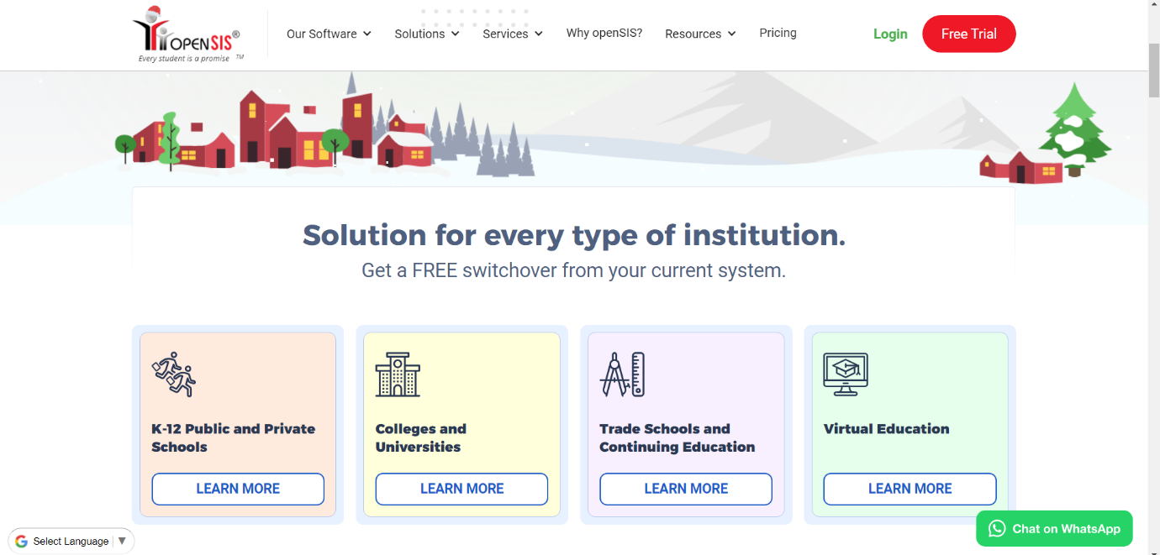
Figure 3:OpenSIS school managemnet Software

2.2.3. Moodle
Overview:
Moodle is a Cloud based software solution providing tools for School Administration, this, system covers three major functions namely; attendance, grading, and communication functions and reporting. Moodle’s main functions are also clear and accessible, its concept built around ease of use for school staff, as well as parents.
Key Features:
- Fee management
- Schedule management
- Communication features for parents, staffs and students
Relevance:
As the system heavily relies on administrative side the software greatly helped by giving ideas as to how the system flow works in admin sided pages

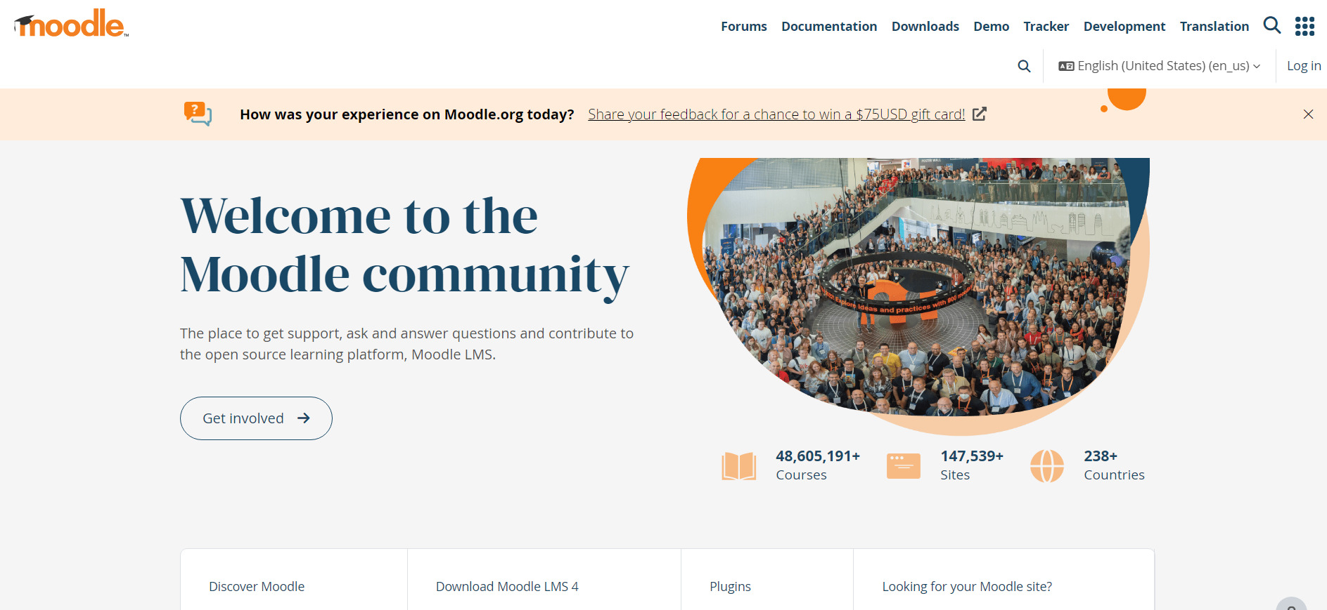
Figure 4:Moodle Software

2.3 Comparison Of the project:

3. Methodologies:
The systematic approach or frameworks used to plan, design, develop, test, and maintain websites and online applications are referred to as methodologies in web development. They offer a methodical approach to project management, guarantee effective teamwork, and produce high-quality outcomes on schedule. Well-known approaches like Agile, Scrum, Kanban and Waterfall provide detailed instructions for allocating responsibilities, setting priorities for developments, and managing modifications. Methodologies are crucial in web development because they help control complexity, enhance team communication, guarantee consistency, and lower the possibility of mistakes, all of which contribute to the creation of more successful, efficient, and user-friendly online solutions.

3 .1 Considered Methodology:

3.1.1 Feature-Driven Development (FDD):
Feature-Driven Development (FDD) was also considered for this project due to its focus on building software through feature-specific tasks, making it well-suited for modular components like user authentication, event registration, and notifications. This methodology provides clear deliverables and iterative progress, which aligns with the project's need for structured development. However, it was not selected because it is more suitable for larger teams and complex projects. Kanban, with its simplicity, flexibility, and visual task tracking, was a better fit for this smaller-scale project, ensuring efficient task management and adaptability

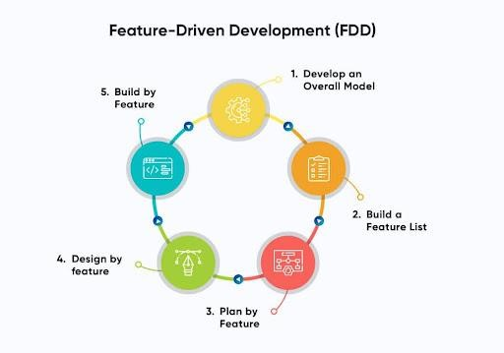
Figure 5:Development process for FDD model (Grorapid Labs, 20024)

3.1.2 Agile Scrum:
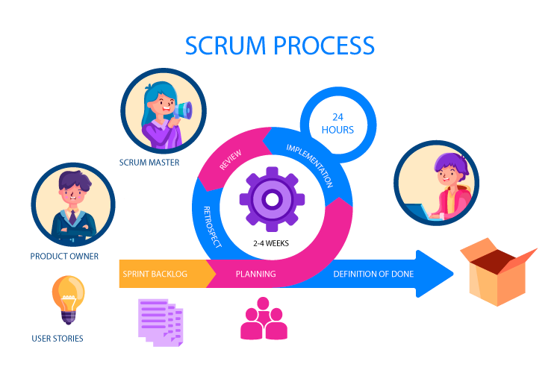
Scrum was taken into consideration because of its systematic approach to continuous improvement using sprints, which enables regular feedback and systematic progress for features like user authentication and event management. But because of its formal procedures and role requirements, which were too complicated for a small team, it was not selected. For this project, kanban's continuous process and simplicity were thought to be more suitable.
Figure 6:Process involved during scrum (Bhaskar S, 2024)

3.2 Selected Methodology:
Among various methodologies, Kanban from Agile was selected as Kanban is a methodology from Agile that helps organize work efficiently by visualizing tasks and identifying problems It uses a visual board with task cards to track progress, reduce waste, and improve workflow. This structured approach ensures timely completion of tasks. Ultimately, Kanban boosts productivity and quality.

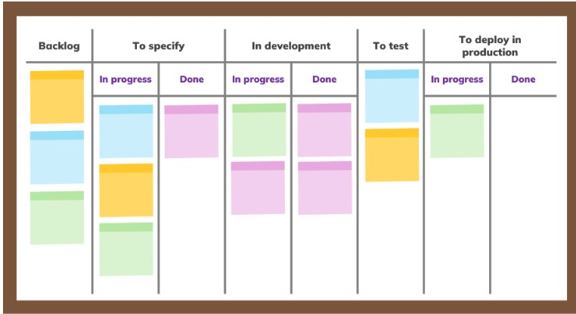
Figure 7:Kanban Board for Software development (Simon Buehring, 2024)

Reason for choosing Kanban for the project:

- Kanban in this project helped to quickly identify which tasks, such as student enrollment and attendance tracking, were in progress or completed. This ensured that project milestones were easily monitored

- The nature of management software is very flexible and requires frequent changes and updates and kanban provided that flexibility by smoothly adjusting priorities without disturbing the progress of other ongoing tasks

- Kanban helped the project by focusing on important tasks like grade management and fee collection, ensuring that no time is wasted on unnecessary steps.

- Any task that was delayed became visible on the Kanban board. This helped to quickly address and resolve issues, ensuring the project was completed on time.

- Due to the nature of Kanban, we are focusing on making small, gradual improvements in the project to avoid big changes to avoid disrupting the entire system. A through testing of system, Refined UI was achieved

3.3 Work Break Down Structure:
A Work Breakdown Structure (WBS) divides a project into smaller, manageable tasks in a structured way. It provides a clear hierarchy of activities, helping teams understand the scope of work. WBS ensures every part of the project is accounted for and organized effectively.

How WBS Helped in My Project:
- Simplified task tracking and ensured smooth progress by clearly defining and organizing each phase of the project.
- Helped identify dependencies and allocate resources efficiently for timely completion.
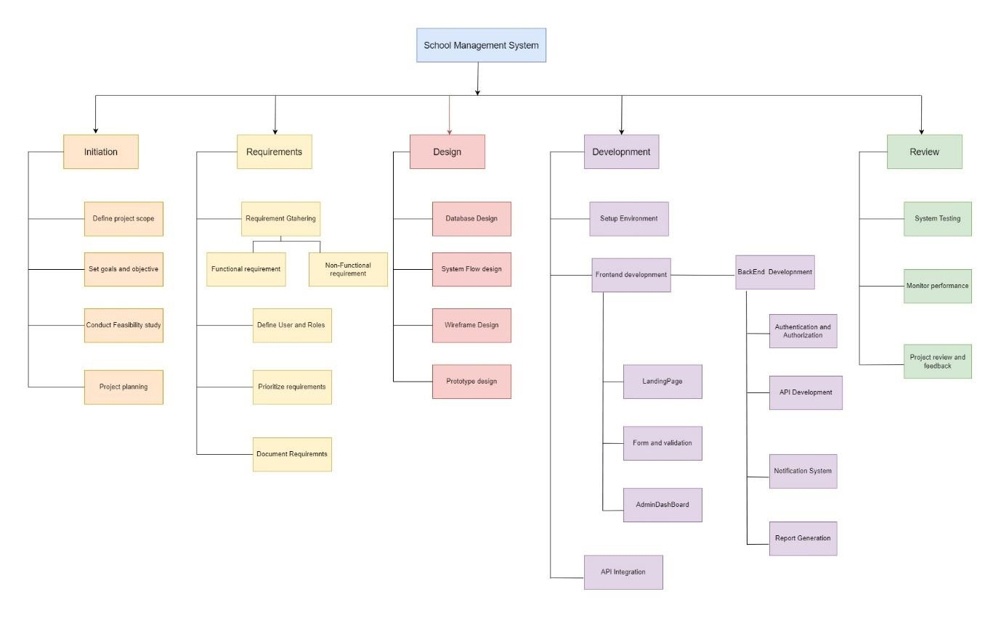
Figure 8: WBS image for the system

3.4 Gantt chart:
The chart below illustrates the work breakdown structure organized by time. As outlined in the milestones section, several key milestones are established throughout the project's duration. The project is expected to take approximately six months to complete, beginning with the initial research and planning phase and concluding with the final project submission. The timeline covers all critical stages, from securing the client and defining requirements to development, testing, and final reporting.

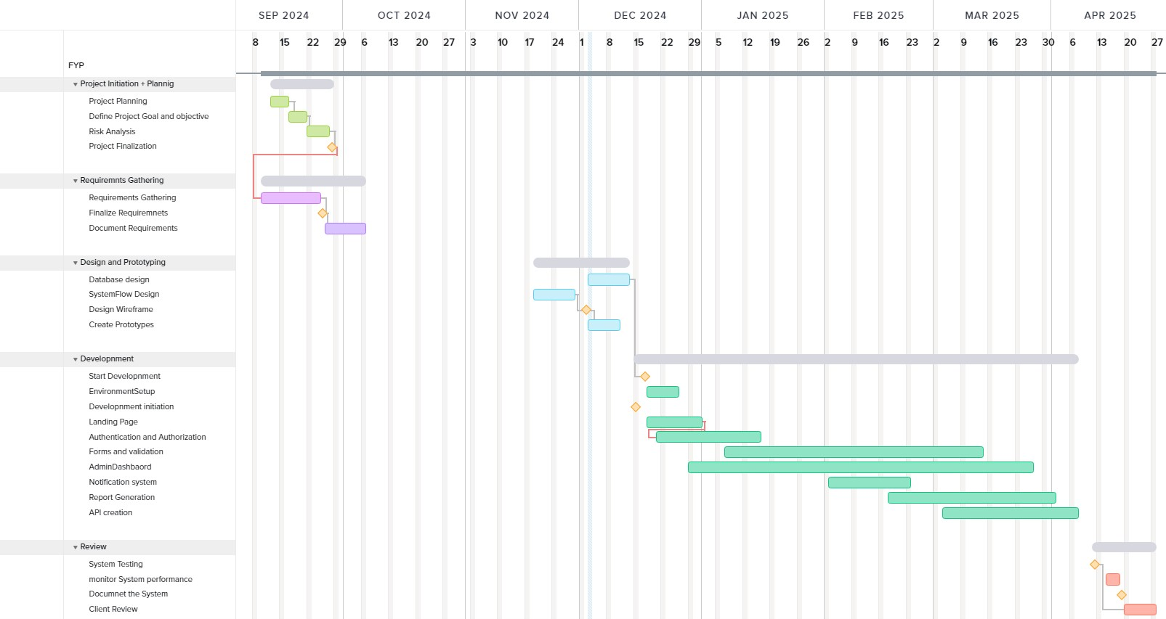
Figure 9: Gantt Chart System

4. Analysis Review:
4.1 Progress Summary:
The project of the development of the school management system website was initiated in order to provide users with an efficient platform to manage the work of schools and to function as a valuable tool effectively, and to achieve both the aims, the project management method called Kanban was used. The project began in early November and the major goal set during the project’s initiation was to create the system that handles user registration and login. Significant advancements have been achieved in the development of the project, with several key milestones completed as outlined below:
- Completed Tasks Login and Registration System: The independent login and the registration system have been established with great efficiency.
- To enhance security, safety and privacy the systems have incorporated One-Time Password (OTP) verification.
- One additional, the “Remember Me” option has also been included to increase convenience for a user.
- Home Page Development: The home page also has been created and put into practice that provides a clear and effective structure of website to enhance the visual aesthetics for users.
Current Progress:
- Event Page Development: Work on the Event Page is underway at the moment. The functionalities to be created pertain to user interfaces’ design as well as their implementation concerning event management. Some of the features being worked on include creation of events, editing, and display of events.
Next Steps
- Finalize the Event Page Development:
- Complete the implementation of event creation, editing, and viewing functionalities.
- Notification System Development:

4.2 Progress Table:
SN | Task | Status | Progress
1. | Project Planning | Completed | 100%
2. | Define Project Goal and Objective | Completed | 100%
3. | Risk Analysis | Completed | 100%
4. | Project Finalization | Completed | 100%
5. | End User and Target Finalization | Completed | 100%
6. | Requirements Gathering | Completed | 100%
7. | Client Specification Finalization | Completed | 100%
8. | Design Schema and tables | Completed | 100%
9. | Create Workflow Diagrams | Completed | 40%
10. | Design Wireframe | Ongoing | 40%
11. | Create prototypes | Ongoing | 40%
12. | Start Development | Completed | 100%
13. | Environment setup | Completed | 100%
14. | Authentication And authorization | Completed | 100%
15. | OTP verification | Completed | 100%
16. | Homepage | Completed | 100%
17. | Forms and validation | - | 0%
18. | Events and registration | - | 0%
19. | Fees and Payment Portal | - | 0%
20. | Notification | - | 0%
21. | Admin dashboard | - | 0%
22. | Report and analysis | - | 0%
23. | RESTful API’S | - | 0%
24. | Integrate API | - | 0%
25. | System Testing | - | 0%
26. | Monitor Performance | - | 0%
27. | Document the system | - | 0%
28. | Client Review | - | 0%

4.3 System Architecture:

The System Architecture Design focuses on how the components of the Blood Donation System should be deployed in order to meet the intended functionality. Basically, it explains the integration of the client-server and data layers, based on the Model-View-Template (MVT) structure that determines Django-based applications.

- Models (Data Layer)
Purpose: Represents the database schema and handles all interactions with the database.
- Each model corresponds to a database table.
- Django provides an ORM (Object-Relational Mapping) for easy querying.
- Views (Business Logic Layer)
Purpose: Acts as a bridge between models and templates, processing HTTP requests and returning HTTP responses.
- Contains the business logic.
- Processes data from models and sends it to templates for rendering.
- Can return JSON responses in APIs (via Django REST Framework).
- Templates (Presentation Layer)
Purpose: Handles the presentation logic and renders data into HTML, CSS, and JavaScript for the frontend.
- Use Django’s template language to dynamically generate content.
- Interact with data passed from the views.
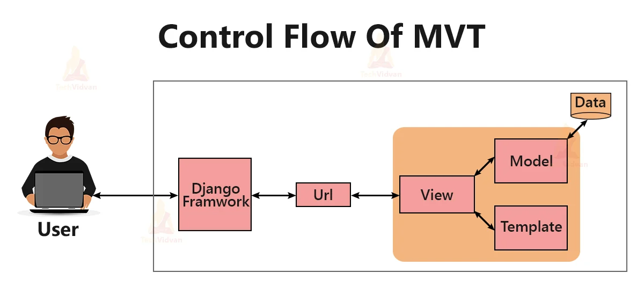
Figure 10:MVT flow in Django (Pain, n.d.)

4.4 ERD:
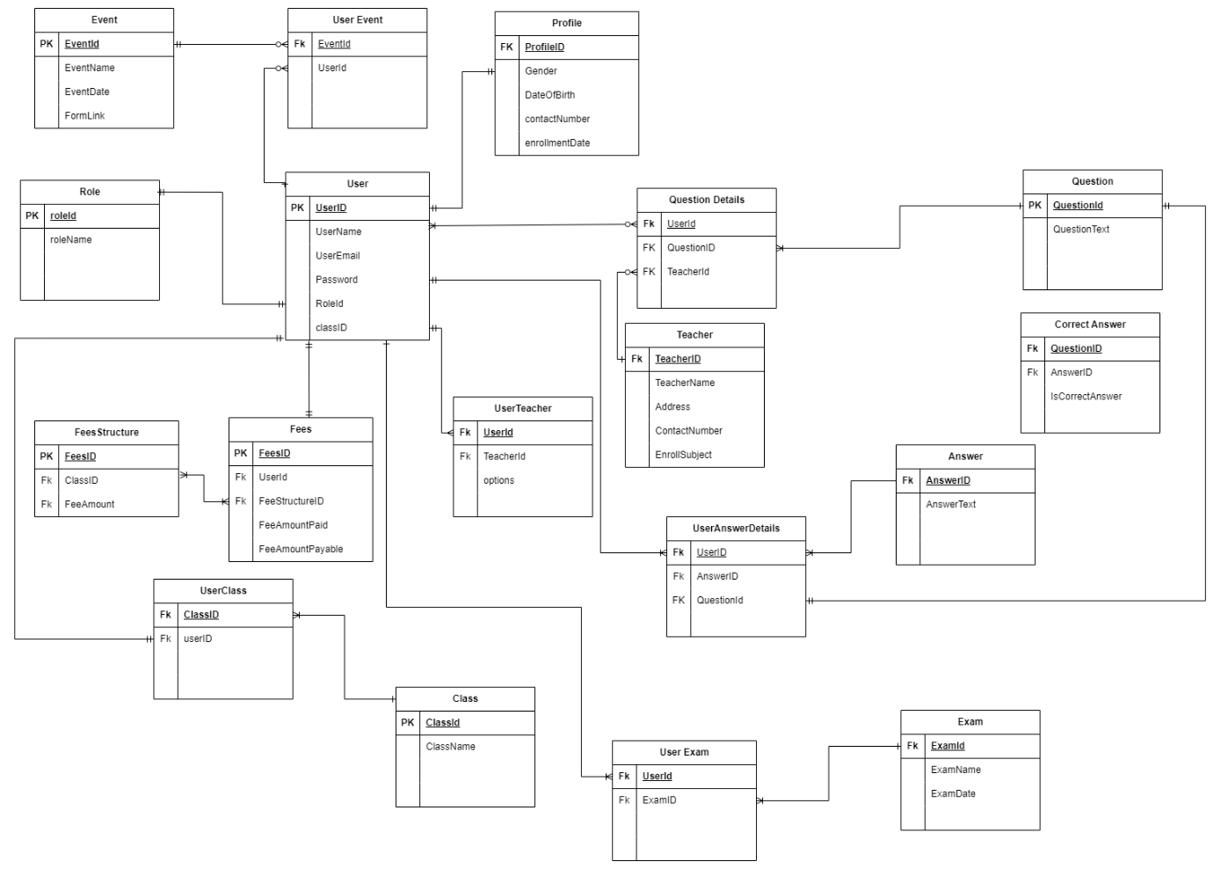
Figure 11:ERD for the system
List OF Entities Used:
- USER: Stores data of all user with in the system\
- EXAM: Stores all the data of exam details
- CLASS: Holds information about and class
- FEE: Stores users fee data
- FEESTRUCTURE: Holds fee structure of every different classes
- QUETSION: Stores question answer to be used in an exam
- EVENTS: Has list of all upcoming event
- EVENTPASRTICIPTAION: gets list of all student who participated in a event

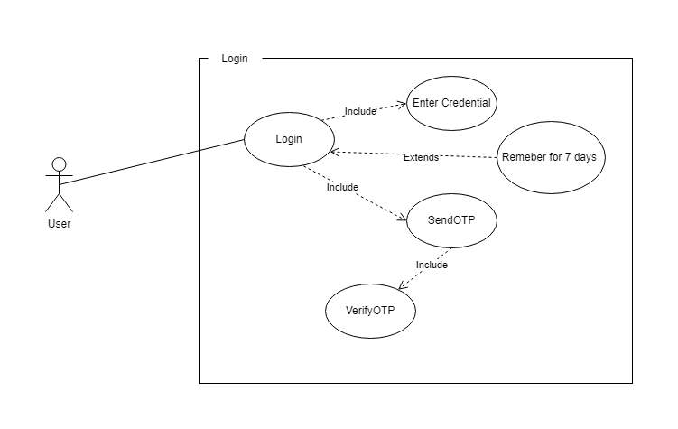
4.5 Use Case Diagrams:

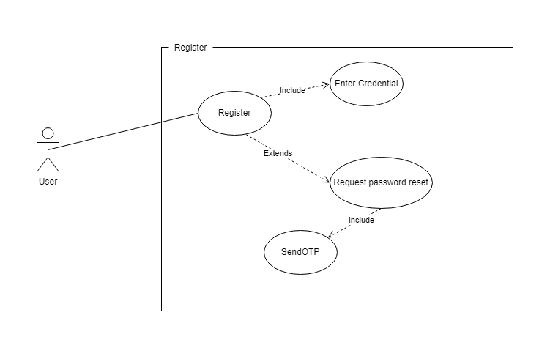
Figure 12: Use case for Login Processs

Figure 13: UseCase For register
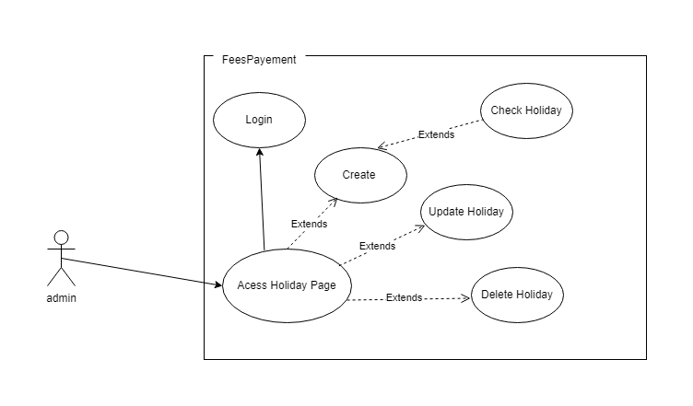

Figure 14: Use Case for holiday Creation

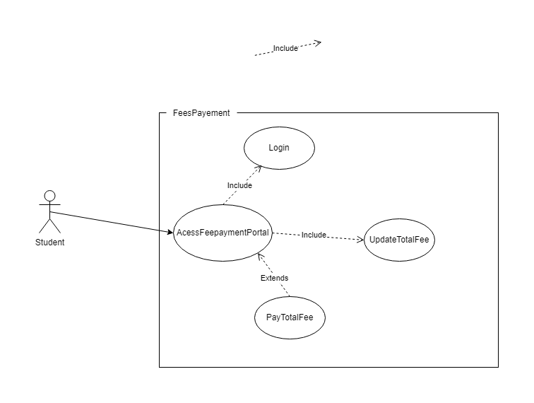
Figure 15: UseCase For Fee Payment

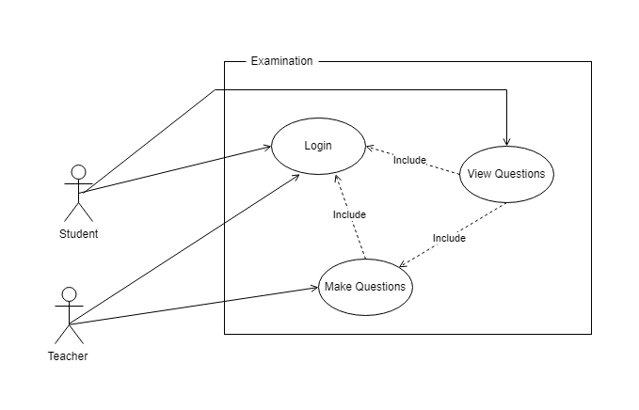
Figure 16: Use For Examinations

4.6 Sequence Diagram:

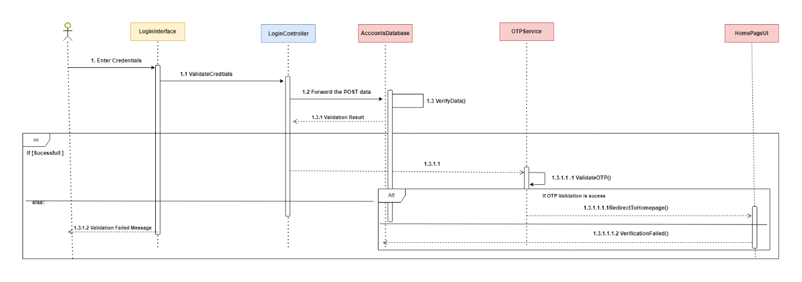
Figure 17: Sequence for login

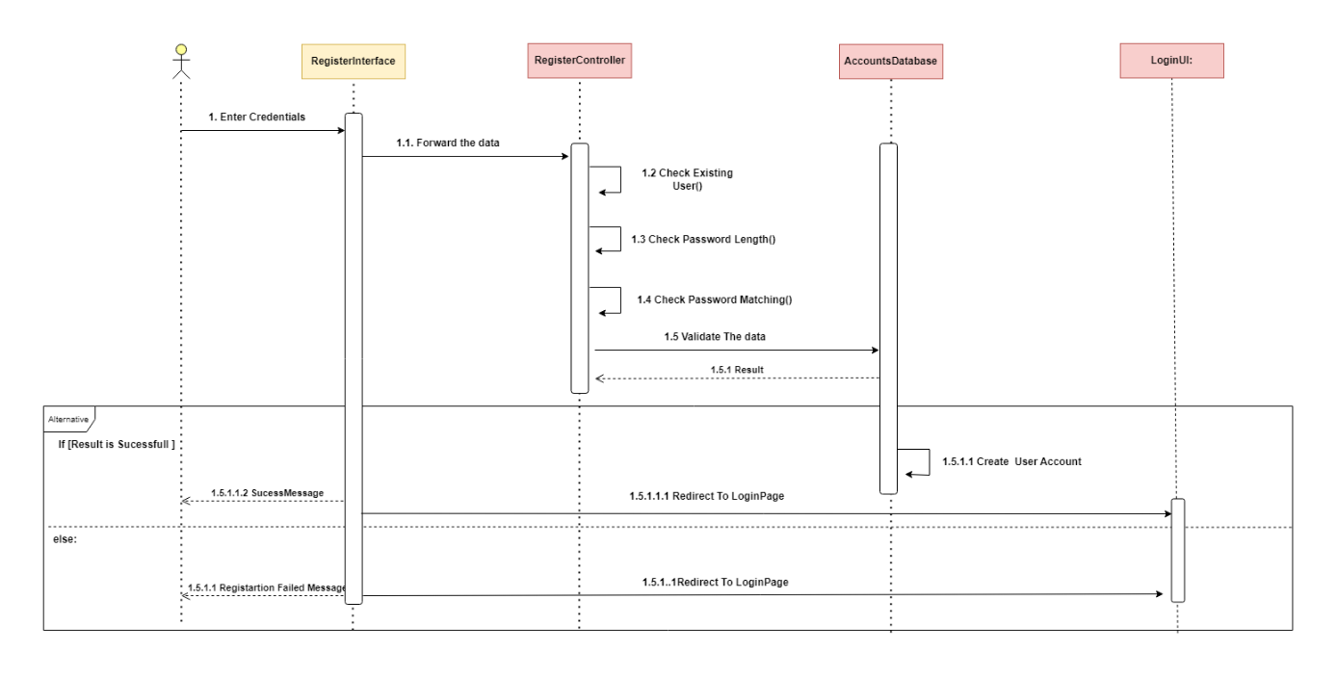
Figure 18:Sequence for Register

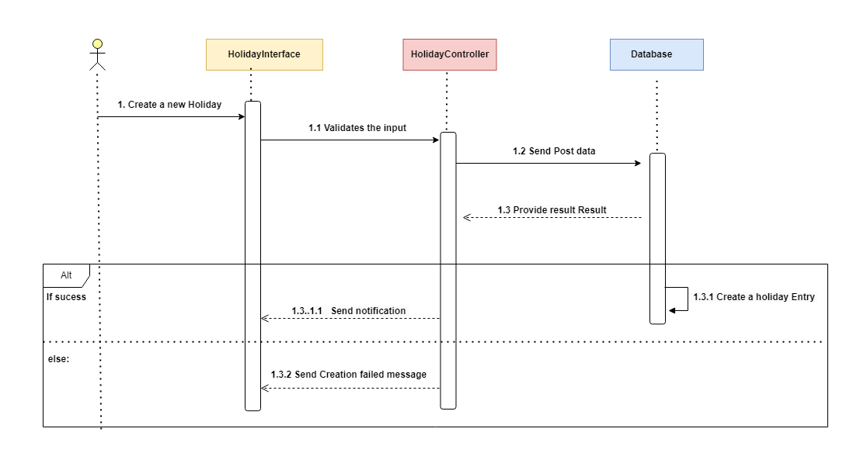
Figure 19:Sequence For holiday

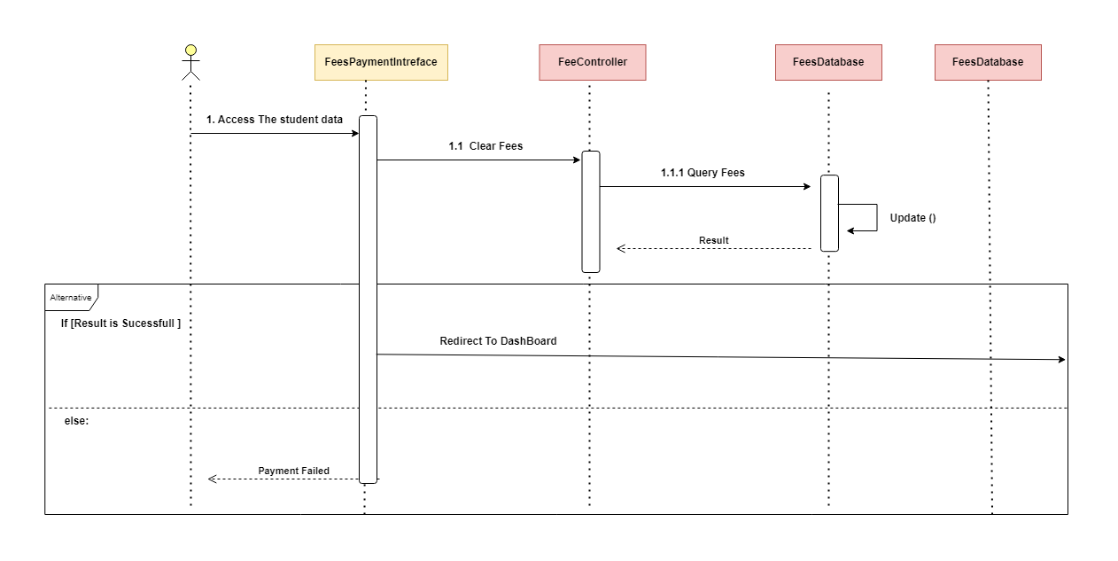
Figure 20:Sequence for Fee Payment

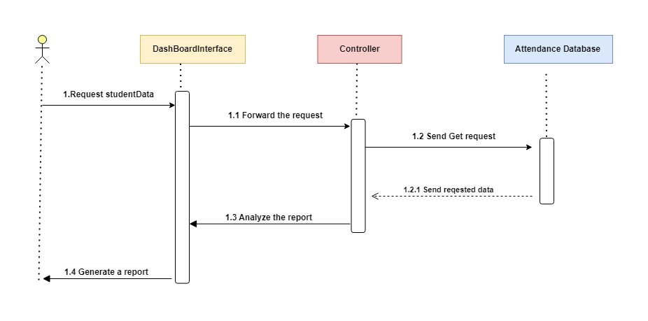
Figure 21:Sequence for Report generation

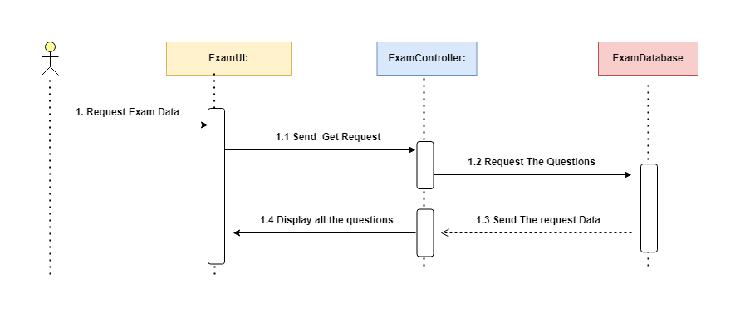
Figure 22:Sequence for Examination UI

4.7 Activity Diagram:

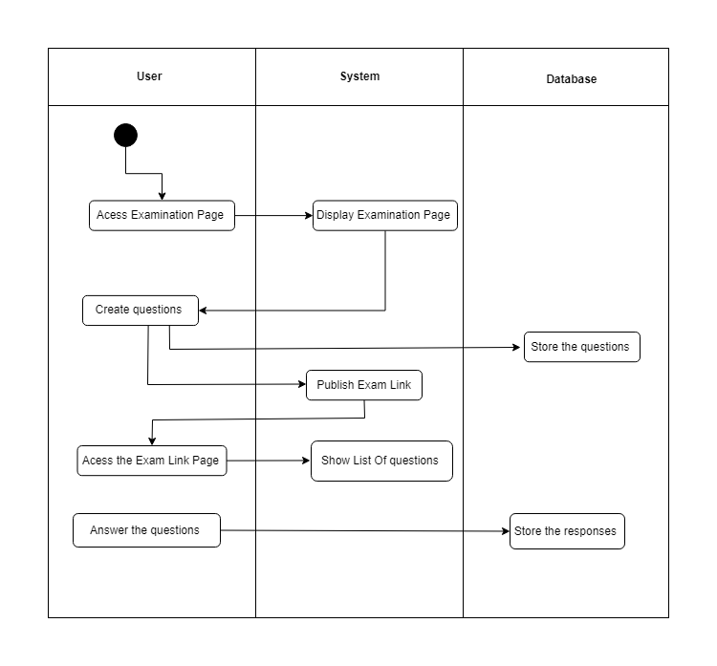
Figure 23:Activity diagram for Examination

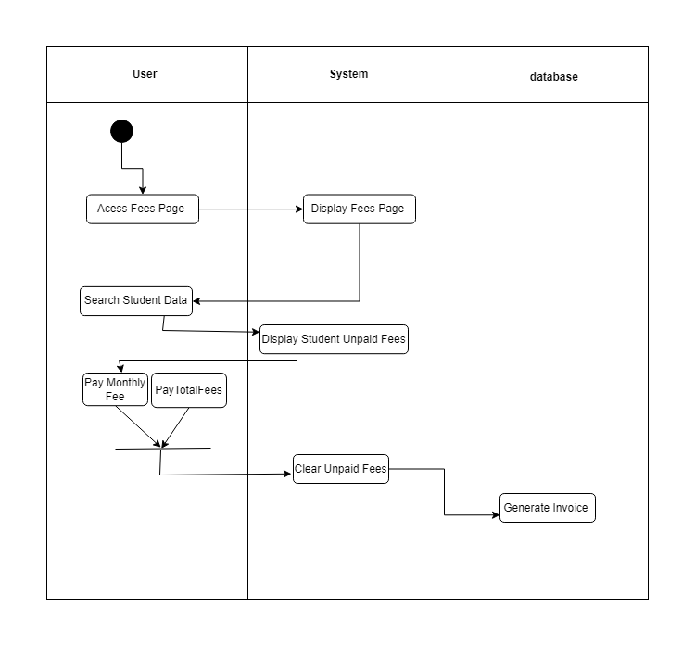
Figure 24:Activity diagram for make payment

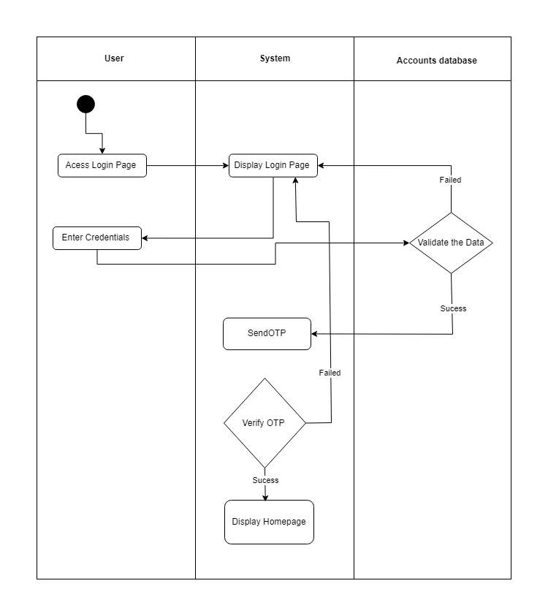
Figure 25:Activity for Login Page

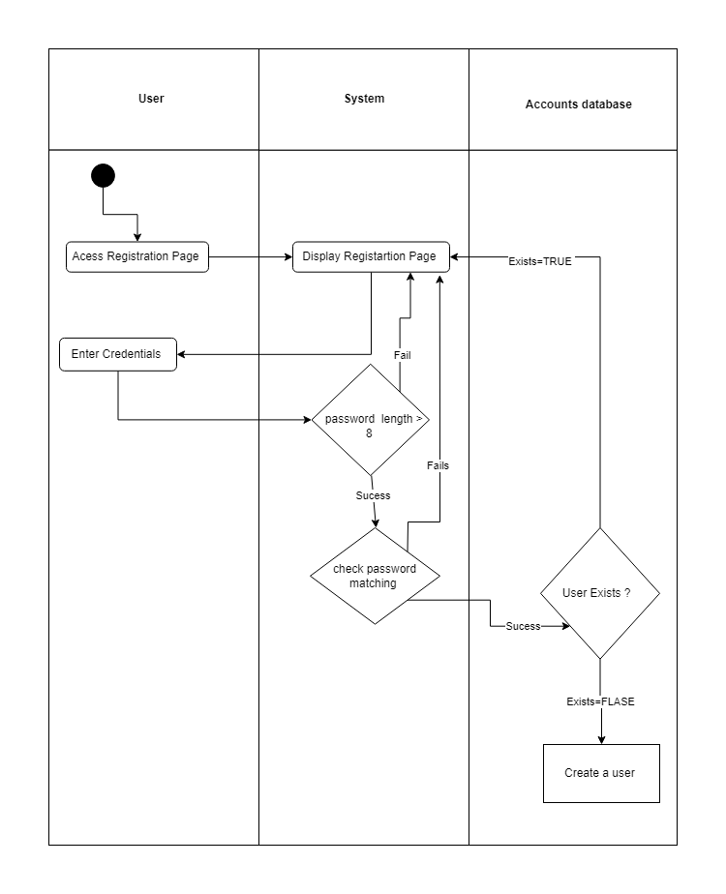
Figure 26:Activity UML for register

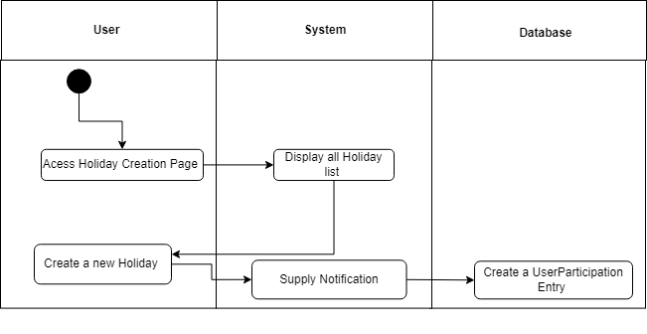
Figure 27:Activity for Holiday

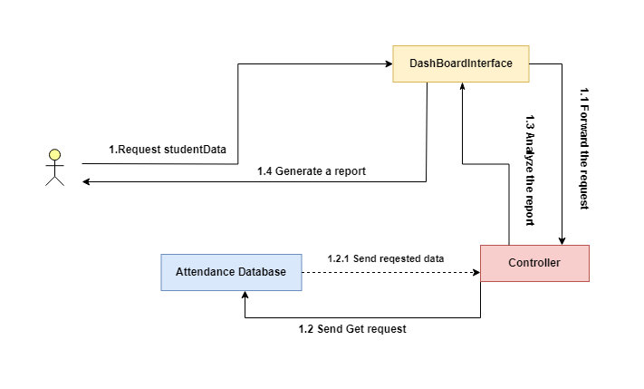
4.8 Collaboration Diagram:
Figure 28:Collaboration for Report Generation

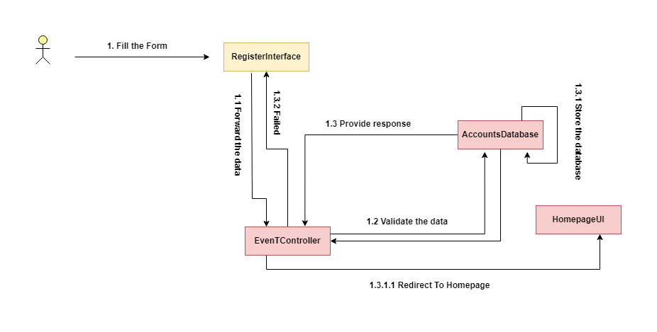
Figure 29:Collaboration for Event

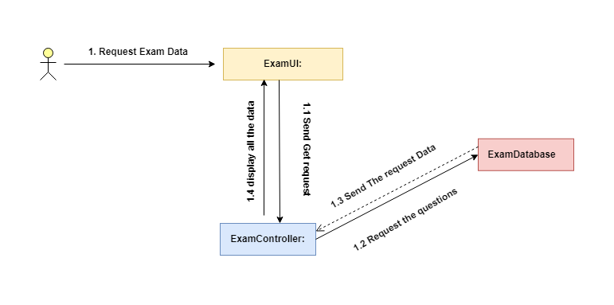
Figure 30:Collaboration for Examination

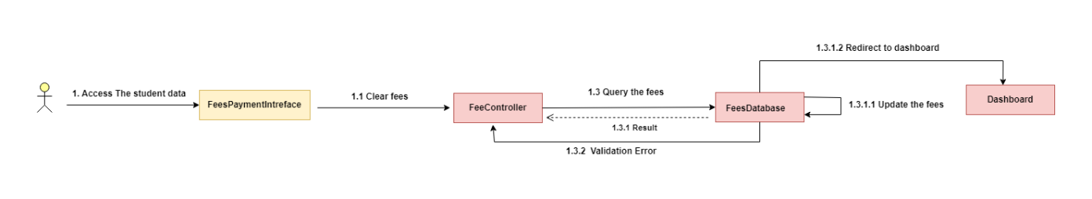
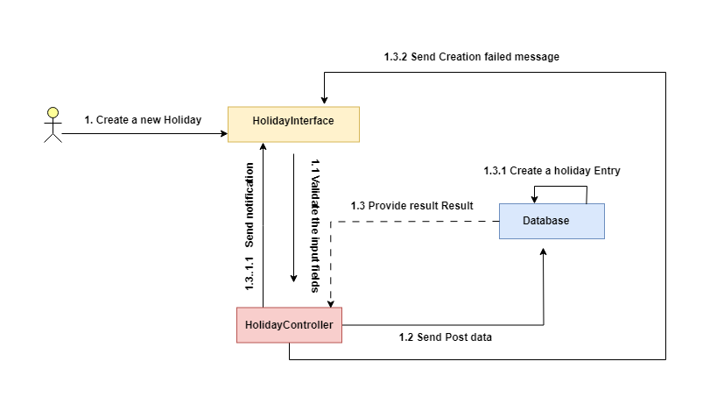
Figure 31:Collaboration for FeesPayment

Figure 32:Collaboration for Holiday Creation

s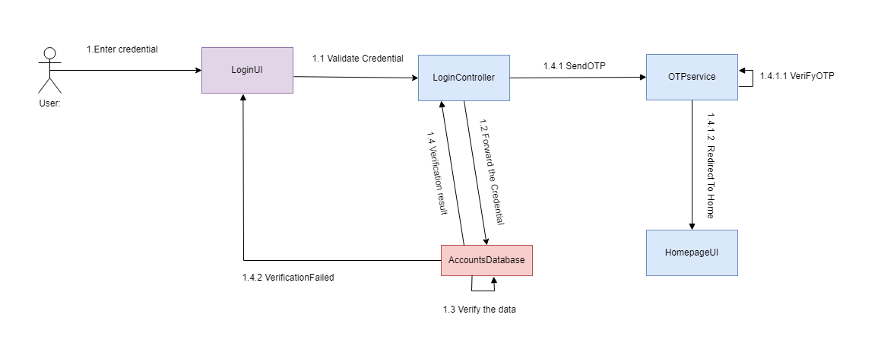
Figure 33:Collaboration for login
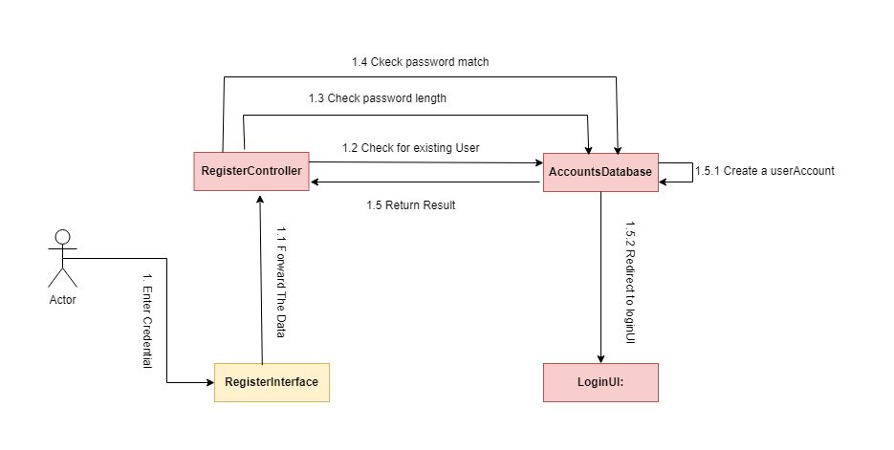
Figure 34:Collaboration for registration

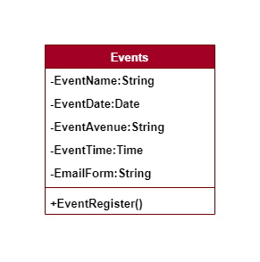
4.9 Class Diagram:
Figure 35:class diagram for Event
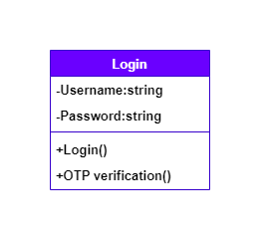
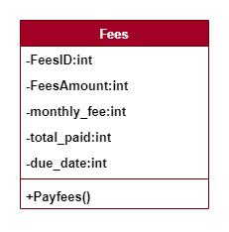
Figure 36:Class Diagram for login
Figure 37:Class Diagram for Fees

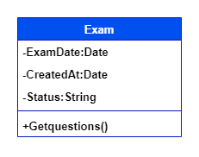
Figure 38:CLassDiagram for Exam
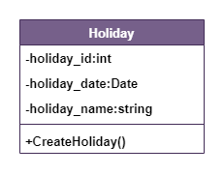
Figure 39: Class Diagram for holiday
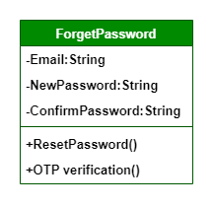
Figure 40:ClassDiagram For forget Password

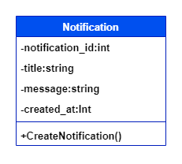
Figure 41:Classdiagram For Notifications
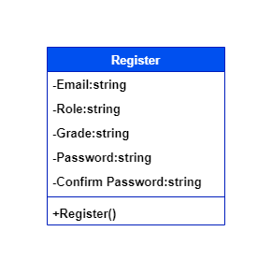
Figure 42:ClassDiagram For Register

4.10 Wireframe:

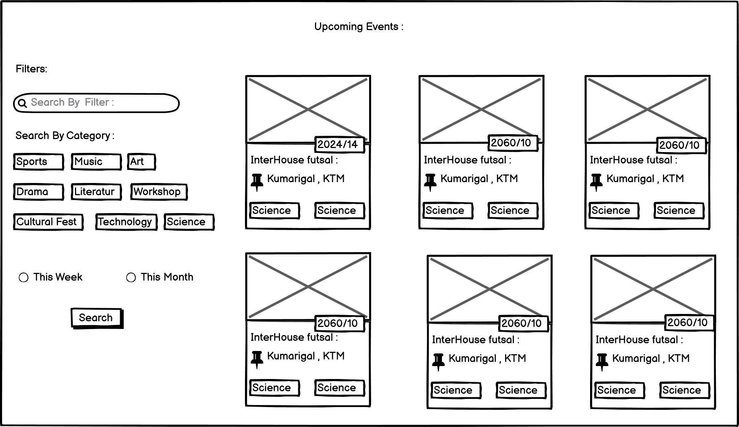
Figure 43:Wireframe for Events page

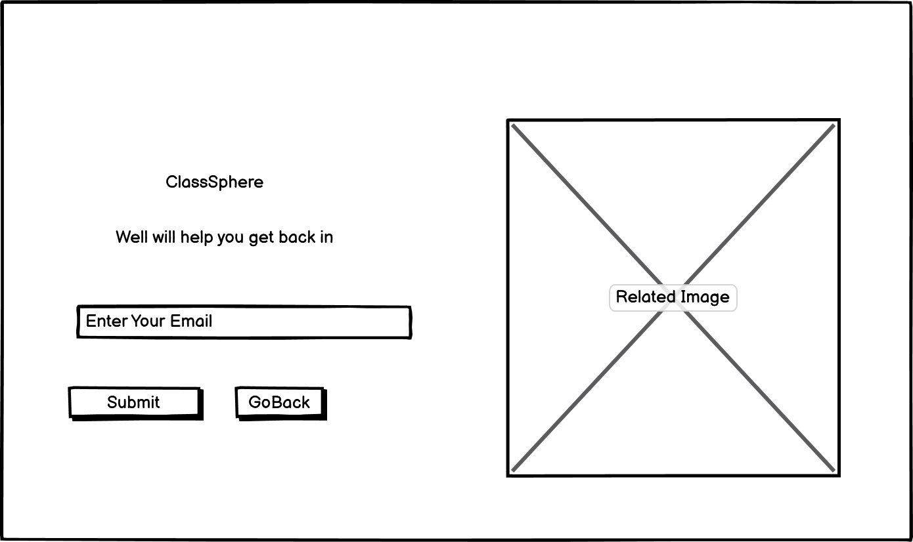
Figure 44:Wireframe for ForgotPasswordPage

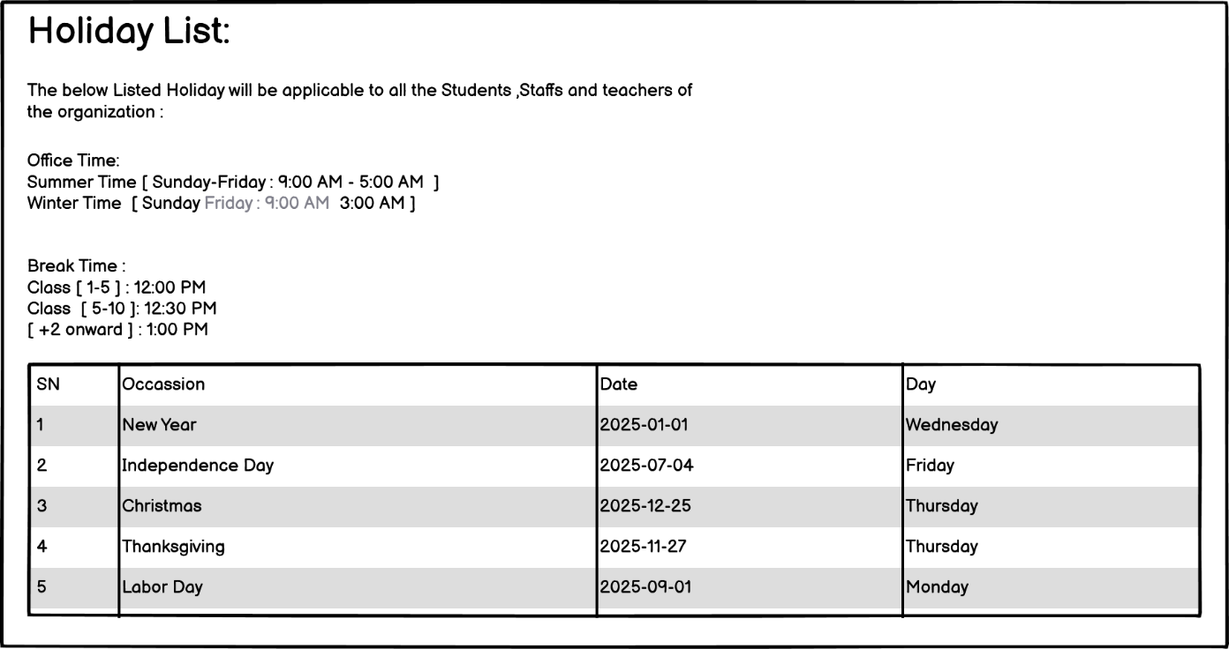
Figure 45:Wireframe for Holiday Page

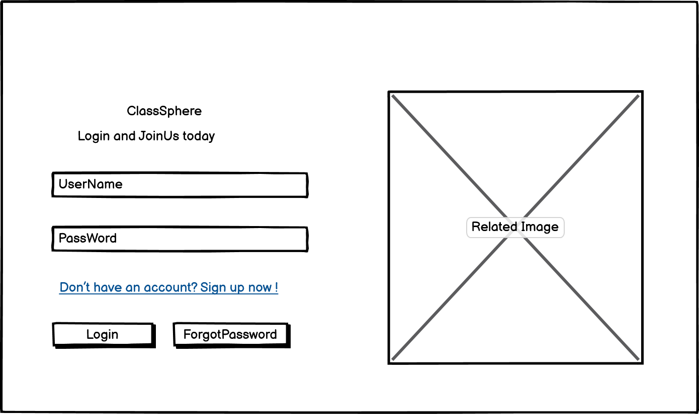
Figure 46:Wireframe for Login

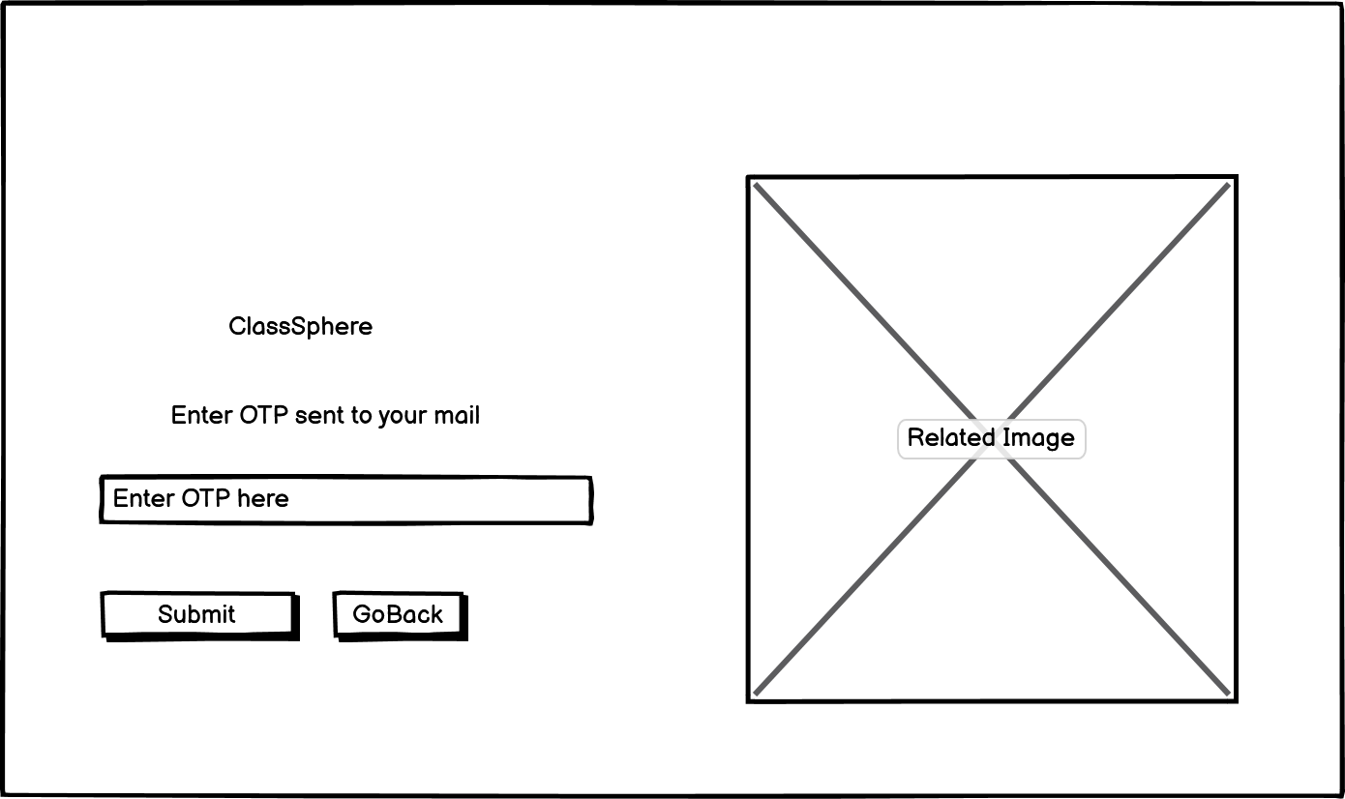
Figure 47:Wireframe for OTP page

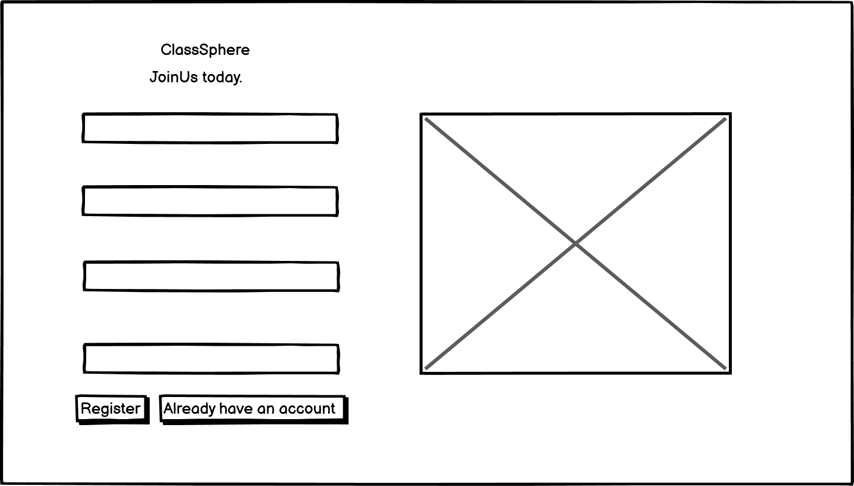
Figure 48:Wireframe for Register

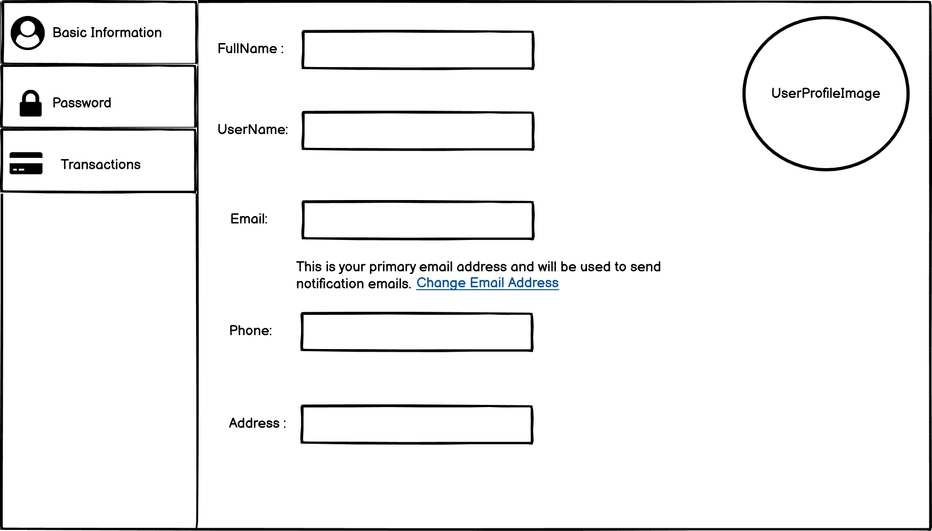
Figure 49:Wireframe for profile


Figure 50:Wireframe for Login

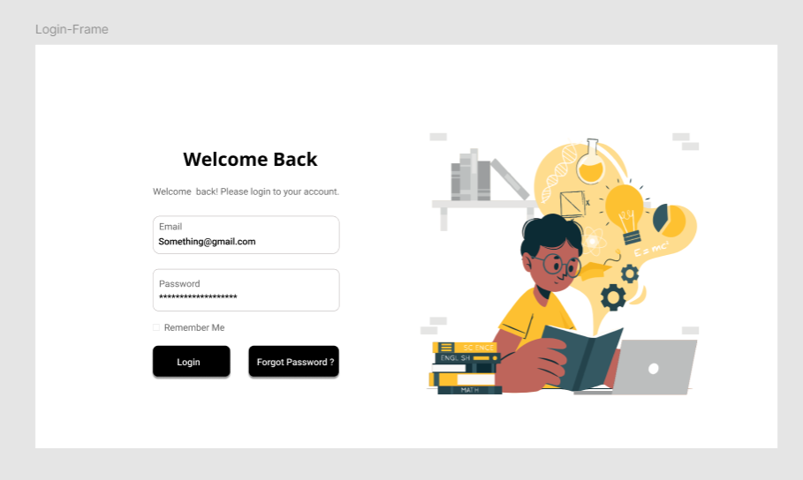
4.11 UI designs:
Figure 51:UI design for login Page
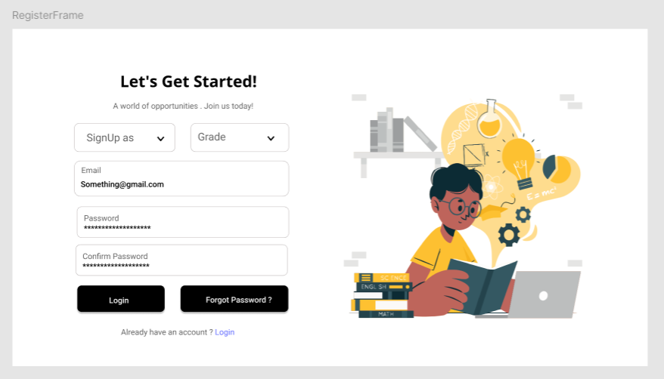
Figure 52:UI for SignUp page


Figure 53:UI for OTP verification Page
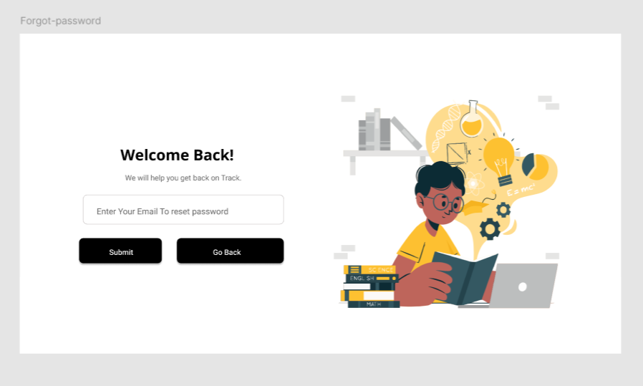
Figure 54:UI for forget Password page

4.12 Development Status With Proof :

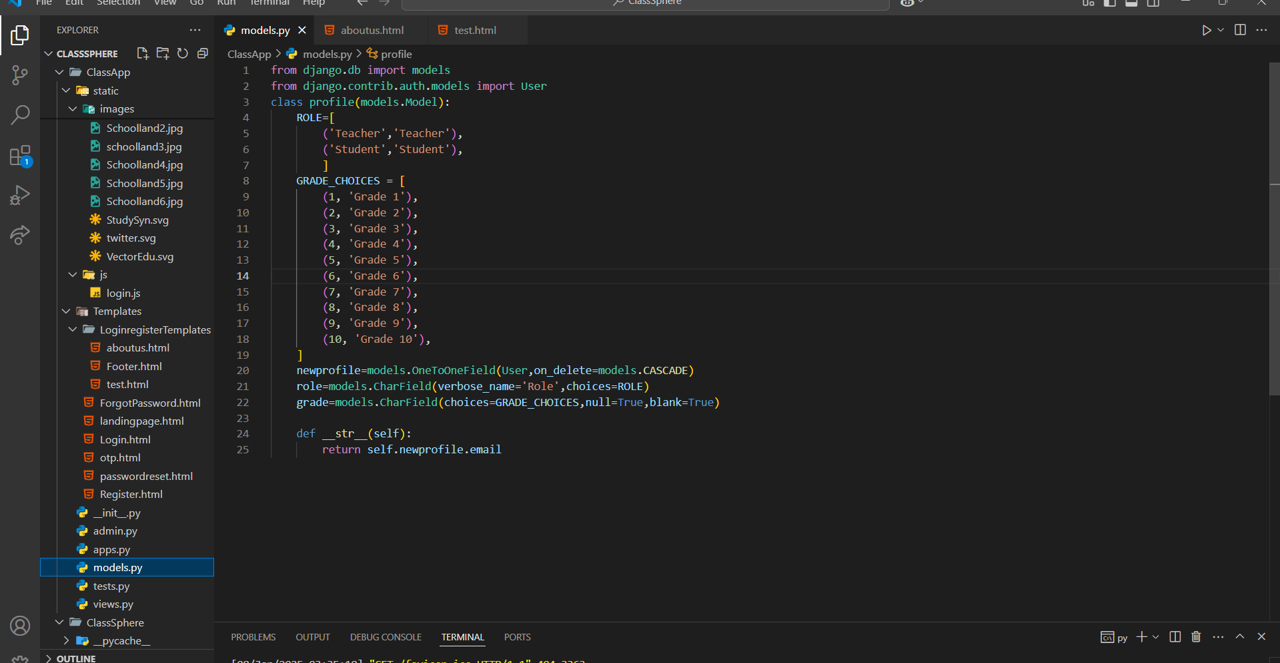
Figure 55: User Extended Model
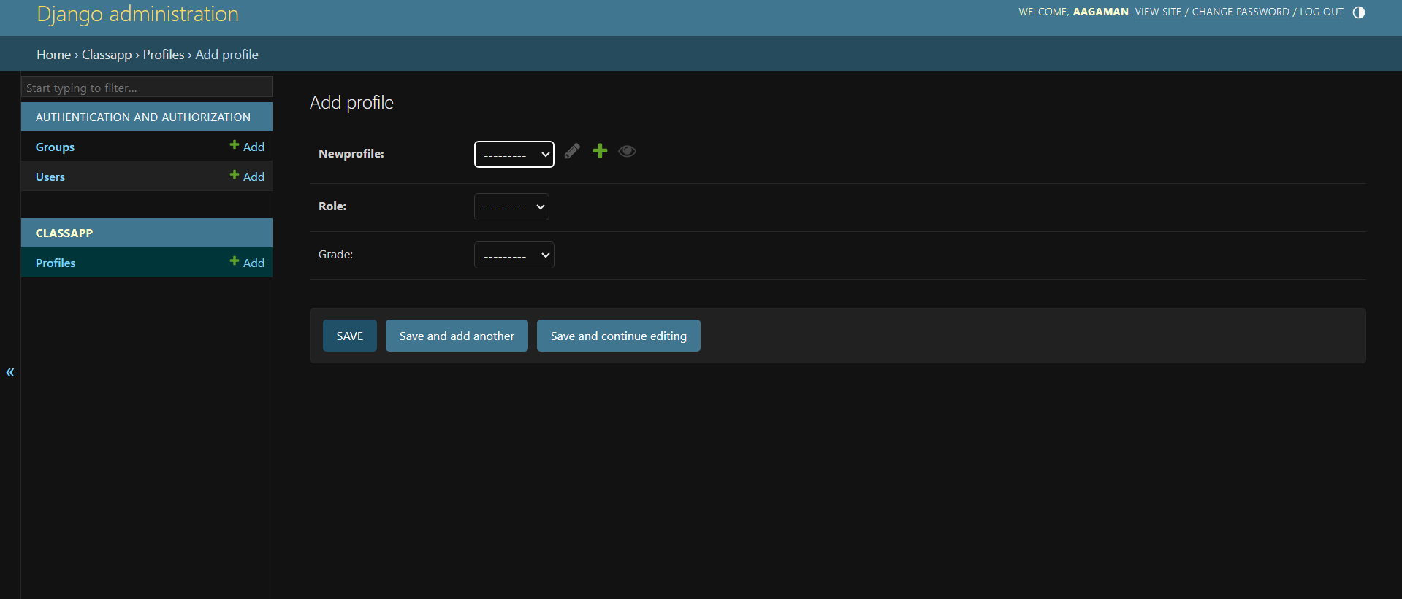
Figure : Django ORM data in Admin page


Figure 56:Password length less that 8
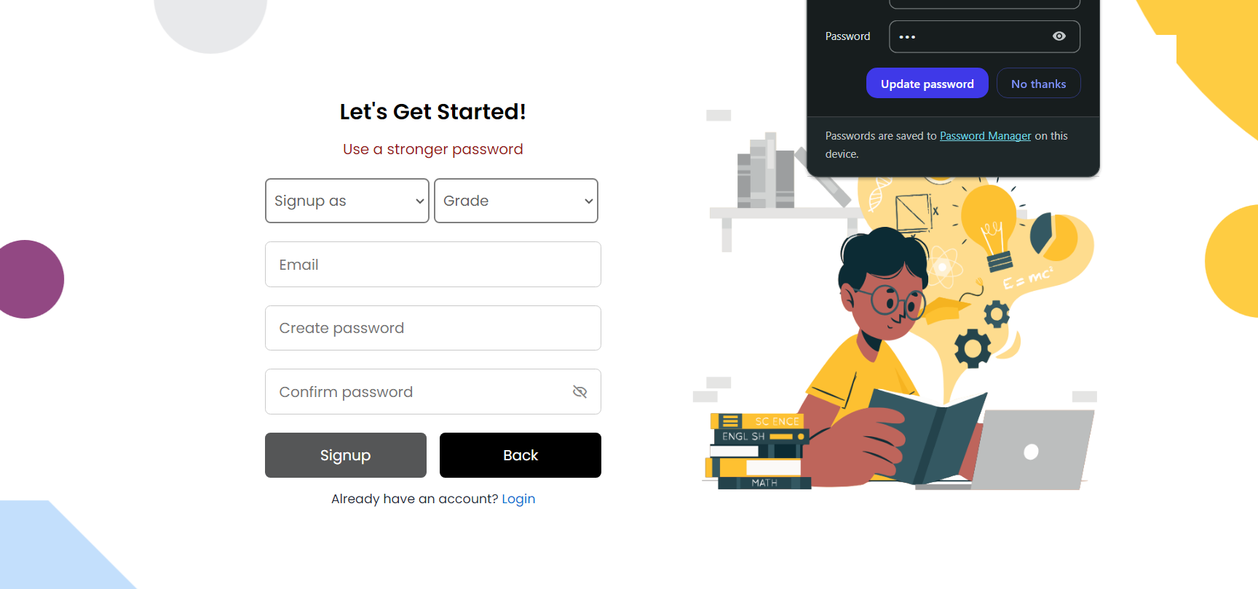
Figure 57:Error message



Figure 58:Validation With diffrent Paasword

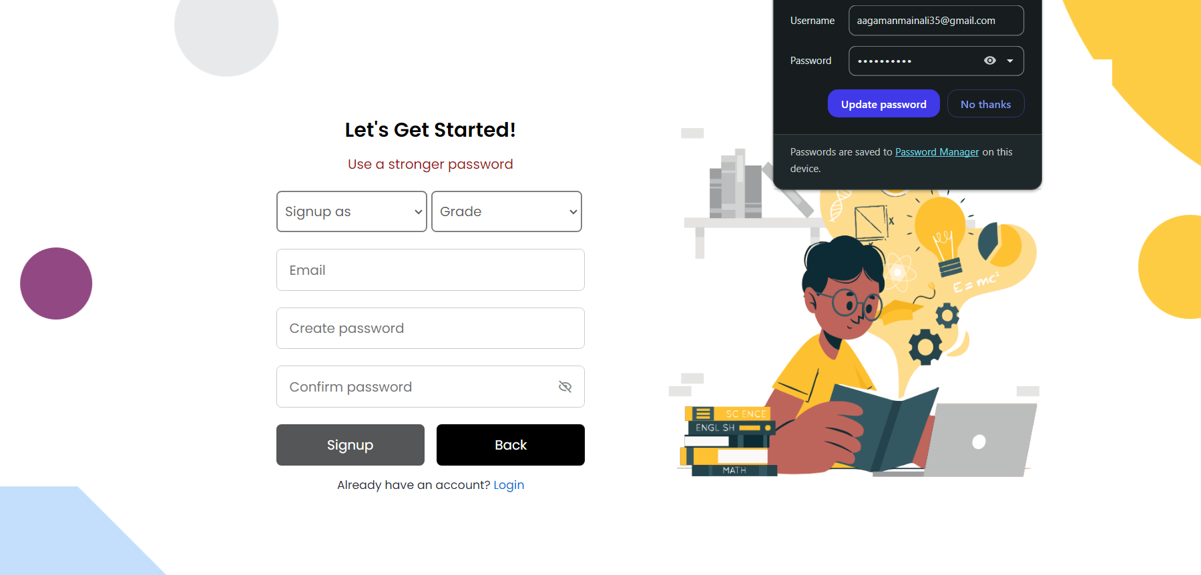
Figure 59:Validation Failed

:
Figure 60:Using the user that already exists:

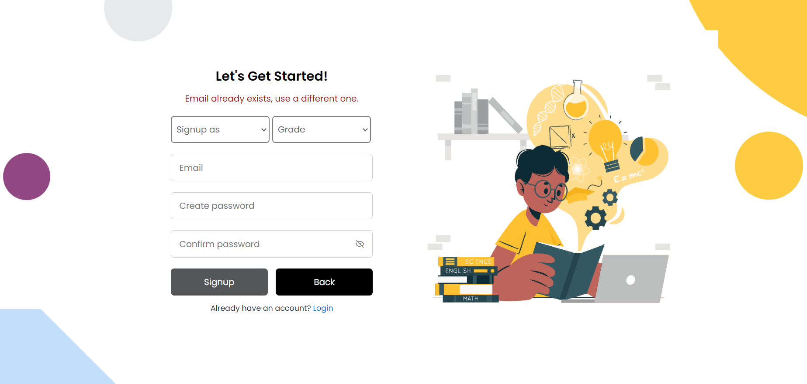
Figure 61:Validation failed due to Unique constraint


Figure 62:SignIN with Proper Data

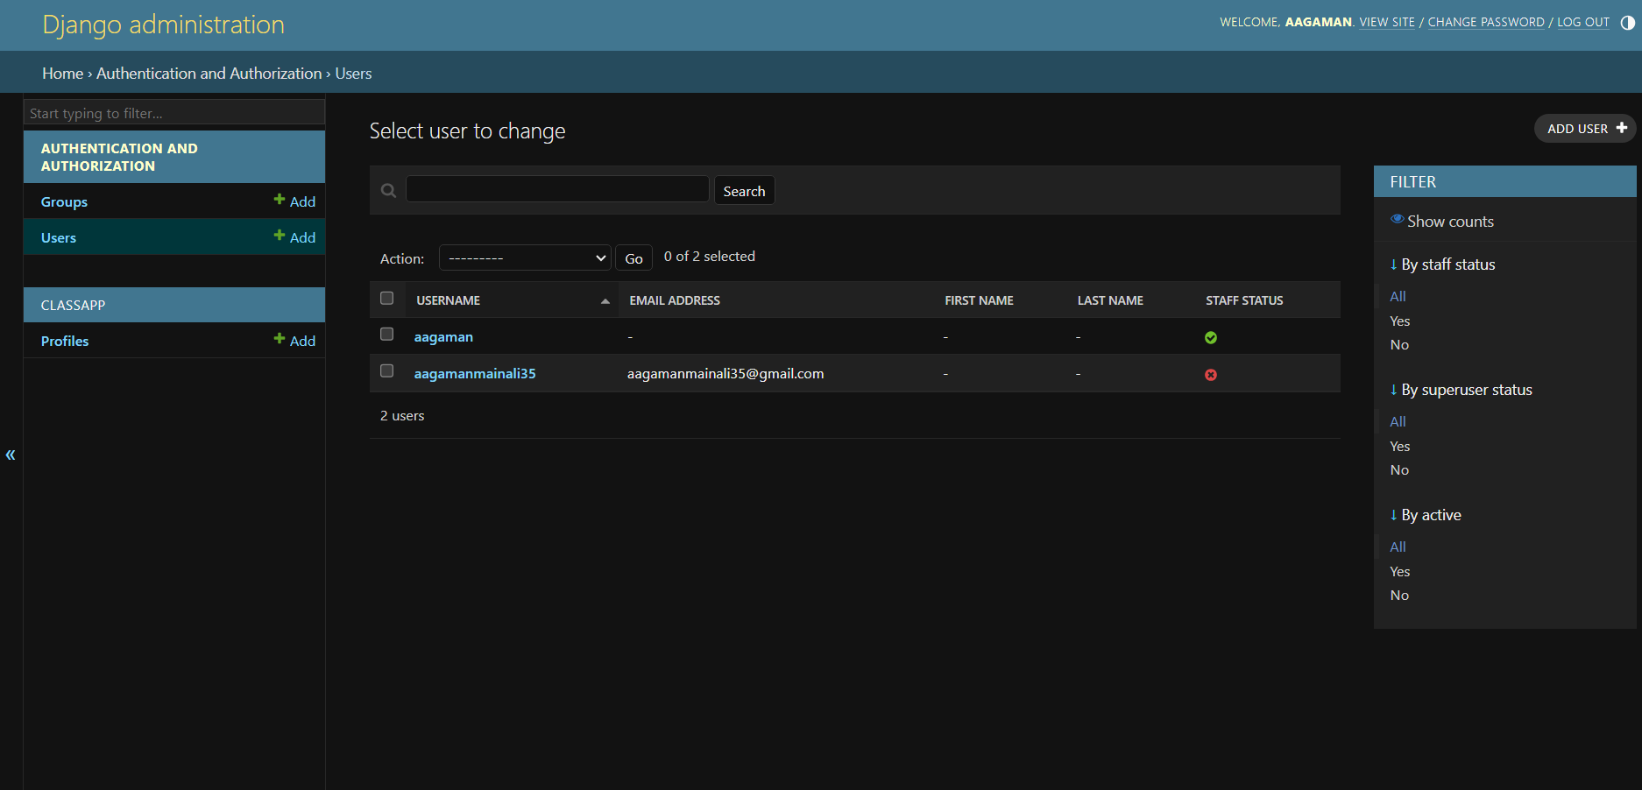
Figure 63:New user created


Figure 64:Using Wrong Password

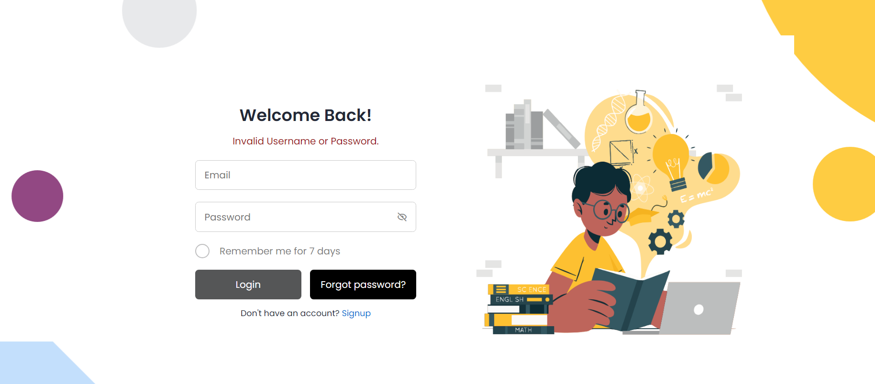
Figure 65:Login Validation Failed

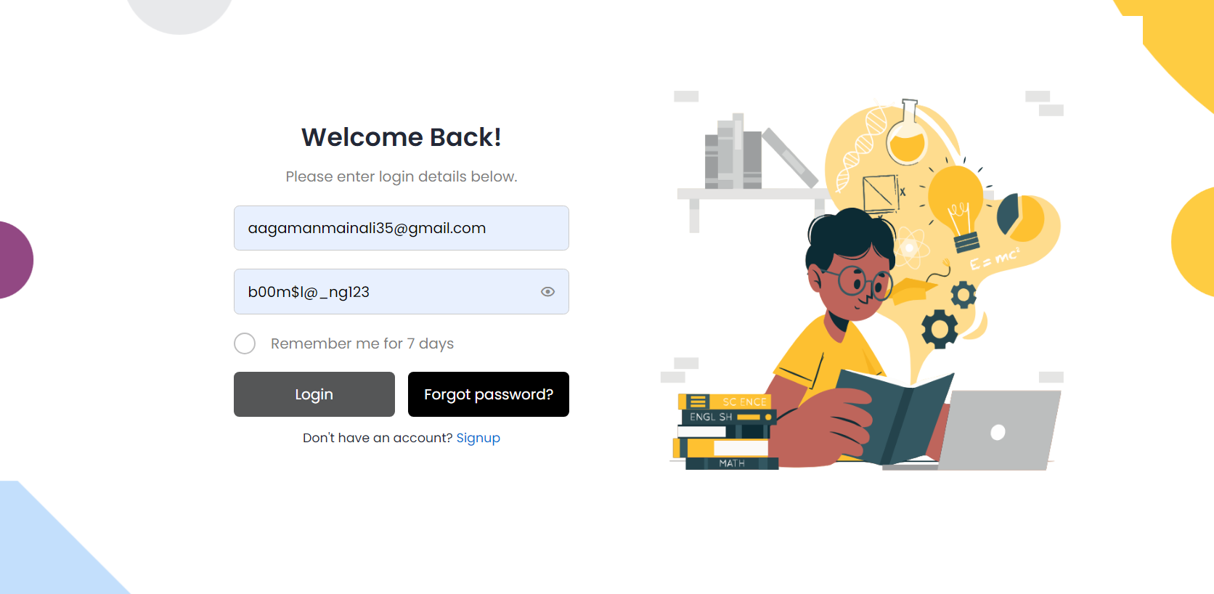
Figure 66:Using Correct Password field

Figure 67:Redirected To login

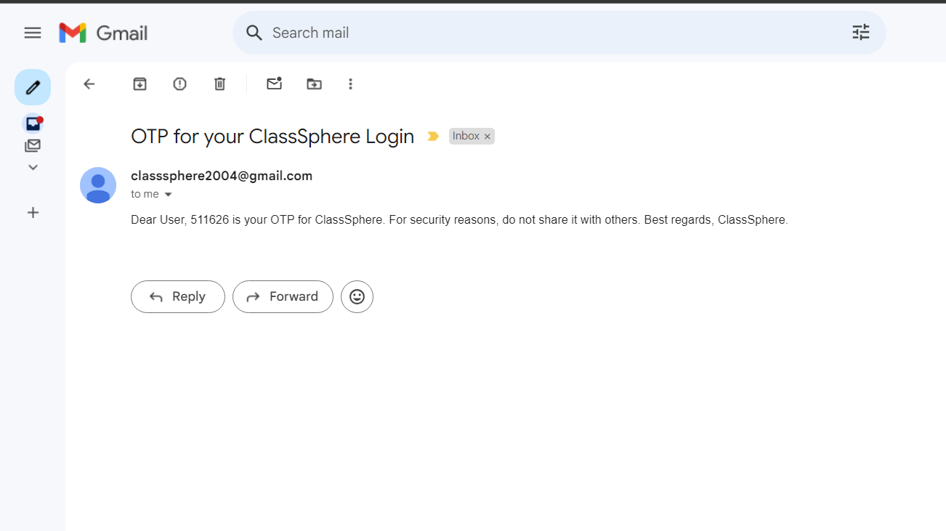
Figure 68:OTP sent


Figure 69:Entered OTP

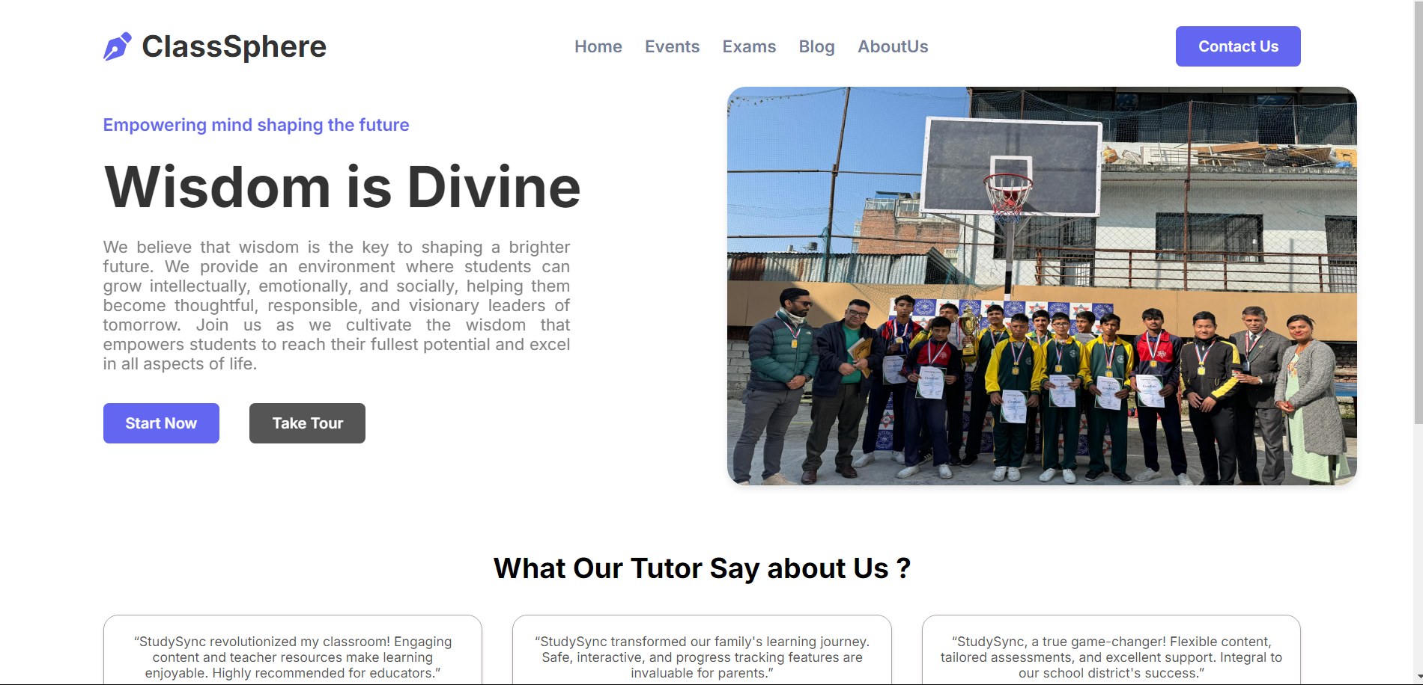
Figure 70:Redirected to login Page

5.Future Works:

5.2 Phase To complete:

- Event Management System:
Develop an easy to navigate design of the Mock Event Page that allows people to view the events and create/mock events.
- Backend Integration: Create and edit events, delete while being able to delete them.
- Notifications: It is also necessary to make notifications regarding new or upcoming events for app users.
Testing: Perform tests to check if events will be displayed, updated and managed in future as expected by the system designers.

2. Notification System:
- Development: Integrated a notification system in order to notify users, reminders, updates, events, or impending deadlines both through their email and within the application.
- Customization: Improve the notification defaults for enabling different alerts, which may be selected or deselected according to interest.
- Testing: Certify the notification delivery mechanism before sending alerts to avoid sending redundancy or delay notifications.

3. Report Generation:
- Automated Reports: Create a reporting framework that will enable the administrators to create ad hoc report on attendance, events and any other statistic.
- Export Options: Include download files templates that will allow a user to download the current report in different formats such as PDF, Excel among others.
- Testing: Make sure they are correct in content, stylized as needed and mobile optimized.

4. Admin Dashboard:
- Development: Develop an effective admin dashboard to enable the administrators to go about the business of adding users, events and managing system settings.

- Role-Based Access Control: Set up proper restrictions of access in order to later control access to materials containing classified data.

- Testing: Do not forget to test all of the admin options in order to avoid any violations of data integrity and miscellaneous issues.

5.Examination System
- Develop a user-friendly interface for students to take exams and view their results.

- Provide separate interfaces for administrators/teachers to create, update, and manage exams.

- Implement role-based access to ensure only authorized personnel can manage exams.

- Enable features for creating exams with multiple question formats such as multiple-choice, short-answer, and essay-type questions.

6.FeesPayment :
- The other important feature of the system should be to enable users to easily access any pending fees and existing payment history as well as fee due dates.

- Provide administrators with tools to configure fee structures, apply scholarships, discounts, or financial aid, and log offline payments.

6. References
Bhaskar S. (2024, November 21). What is Scrum Methodology? An Introduction for Agile Teams. Retrieved from nimbleWork: https://www.nimblework.com/agile/scrum-methodology/
edigitalnepal. (2024). Retrieved from https://edigitalnepal.com/p/the-current-scenario-of-education-system-in-nepal-how-digital-nepal-helping-to-schools-to-uplift-their-standard-3612
Grorapid Labs. (20024). Retrieved from https://www.grorapidlabs.com/blog/feature-driven-development-how-to-build-user-centric-products
MordorIntelligence. (2024). Retrieved from https://www.mordorintelligence.com/industry-reports/school-information-management-system-market
Pain, A. (n.d.). Understanding the MVT Architecture in Django. Retrieved from https://www.linkedin.com/pulse/understanding-mvt-architecture-django-aritra-pain-fpmnc/
Simon Buehring. ( 2024, April 3). Kanban board examples. Retrieved from https://agilekrc.com/agile/kanban/kanban-board/kanban-board-examples
theschoolmanagement. (2024). Retrieved from https://theschool-management.com/most-10-common-problems-in-school-management-system/

